Data Port Quick Find for ECERF Building

(PHP Zend Framework Version)

USER’S MANUAL

USER'S MANUAL

TABLE OF CONTENTS

Page #
Contents
PHP Zend Framework Version i
1. GENERAL INFORMATION 1
1.1 System Overview 1
1.2 Authorized Use Permission 1
2. WEB SERVER SETUP FOR THE APP 1
2.1 Apache Setup 1
2.2 Microsoft Internet Information Services (IIS) 1
2.3 MySQL Database 2
3. PRESENTATION OF THE APP 2
3.1 Search by Data Port Number 2
3.2 Search by Room Number 4
3.3 Add Path Nodes 4
3.4 Manage Edges 5

GENERAL INFORMATION

1.1 System Overview
This simple local web app that can run on localhost is built using PHP Zend Framework and MySQL. Its main function is finding a specified Data Port in ECERF building and drawing the shortest path from the floor’s main entrance to the destination (the data port). You also can get a data post list for a specified room. The Add Path Nodes subpage is used to create path nodes and add an edge of node to node in case some renovation will block the hallway in the future.

1.2 Authorized Use Permission
Usage of this software is limited to every authorized staff.

wEB SERVER SETUP for the App

Apache Setup
To use Apache, setup a virtual host to point to the public/ directory of the project. Append virtual host info in file “httpd-vhosts.conf “(the file is typically located at c:\Apache24\conf\extra). It should look something like below:
<VirtualHost portmap.localhost.com:8080>
ServerName portmap.localhost.com
DocumentRoot C:/WebApp/port_map_php/public
SetEnv APPLICATION_ENV development
<Directory "C:/WebApp/port_map_php/public">
DirectoryIndex index.php
AllowOverride All
Order allow,deny
Allow from all
<IfModule mod_authz_core.c>
Require all granted
</IfModule>
</Directory>
</VirtualHost>

Microsoft Internet Information Services (IIS)
- Open notepad as administrator user
- Add an entry to your hosts (file) like – “127.0.0.2 portmap.localhost.com” [one host in each line]. The hosts file is typically located at C:\WINDOWS\system32\drivers\etc\hosts
- Now save the hosts file and close
- Last create an entry in your IIS by following http://support.microsoft.com/kb/816576 with the above host name, i.e. portmap.localhost.com. Set the physical path to point to port_map_php\public directory

MySQL Database
This web app is using MySQL, via PHP’s PDO driver, so run SQL script “dataport_phpMyAdmin” (the file is located at \ port_map_php\module\Dataport\data) to import “dataport” database.
Then modify the username and password of MySQL in file “local.php “(the file is located at \port_map_php\config\autoload ) to access the database. It should look something like below:
return array(
'db' => array(
'username' => 'guest',
'password' => '',
),
);

presentation of the app

Search by Data Port Number
The default floor number is 3. Or you can select desired level from left side level bar.
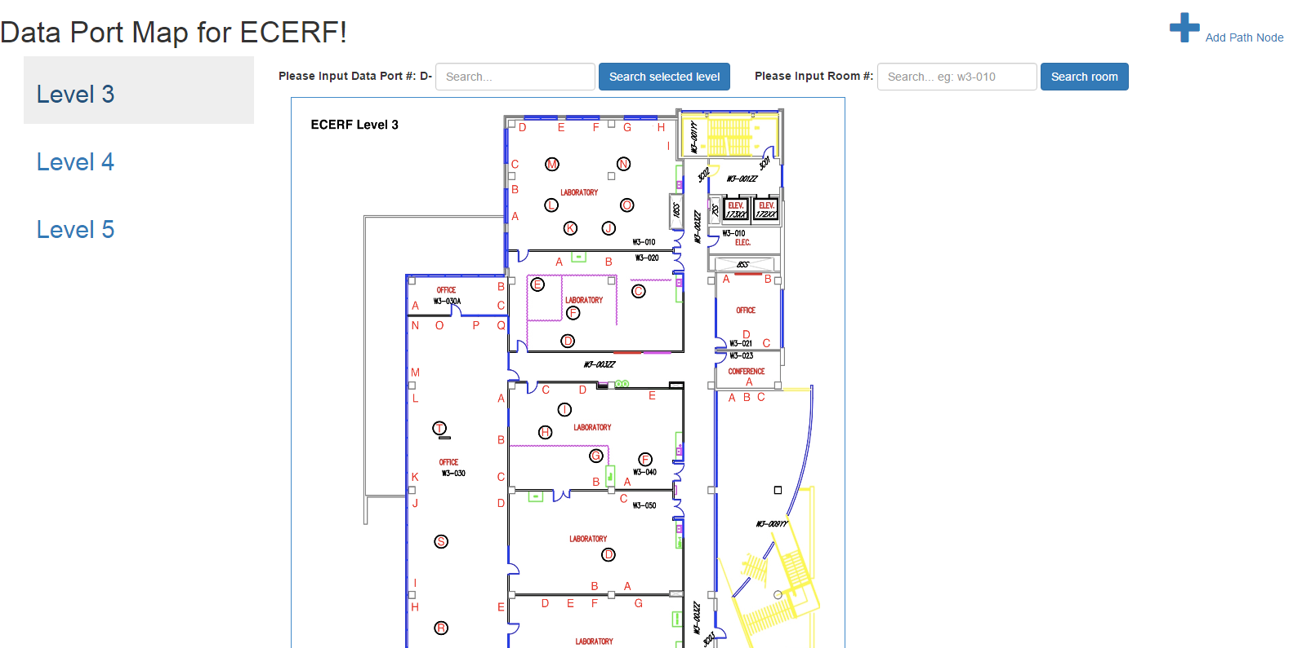
Searching interface

If the desired data port is exist, its detail will be displayed, a blinking circle will be printed overplay on the floor map. Meanwhile if the data port’s location is known, the shortest path from the floor’s main entrance to the destination will be drew.

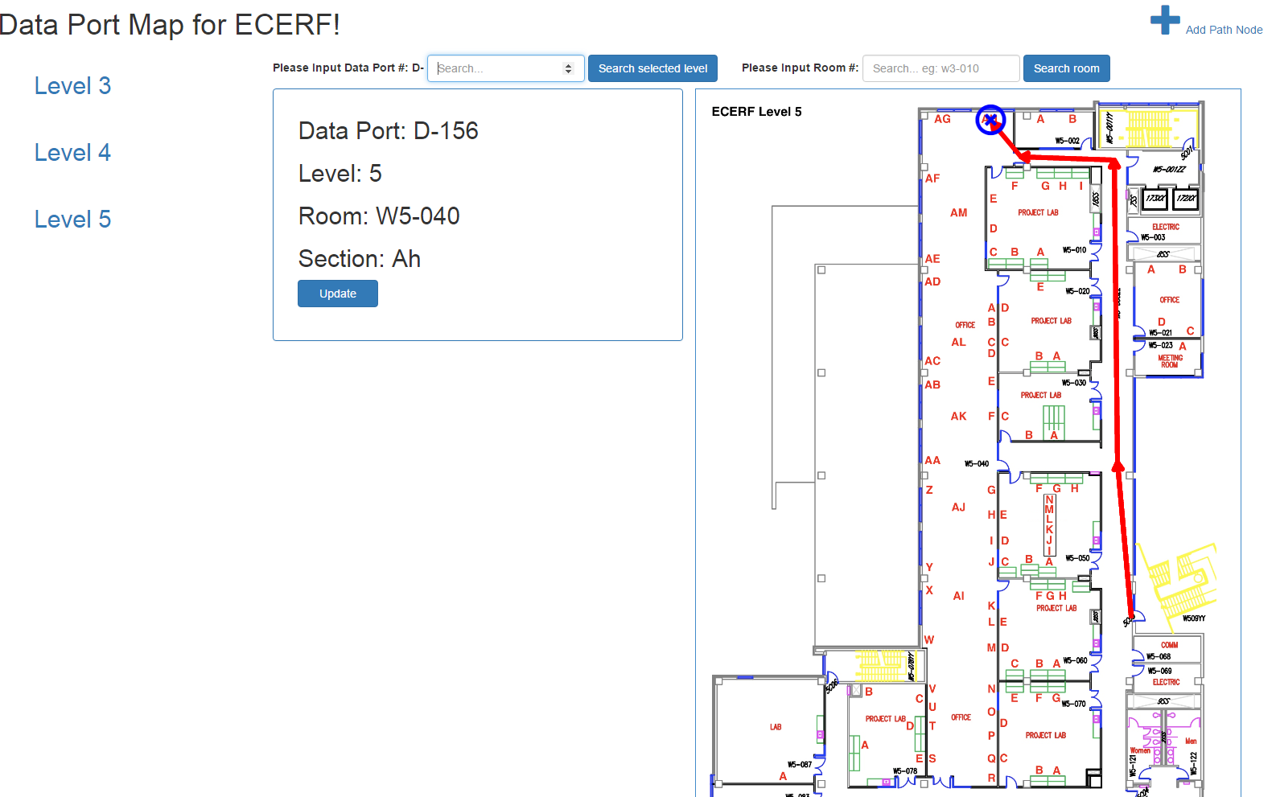
Search Result

If you think that the coordinate of the data port is wrong, you can update it by clicking  button. Then click the new coordinate on the map.
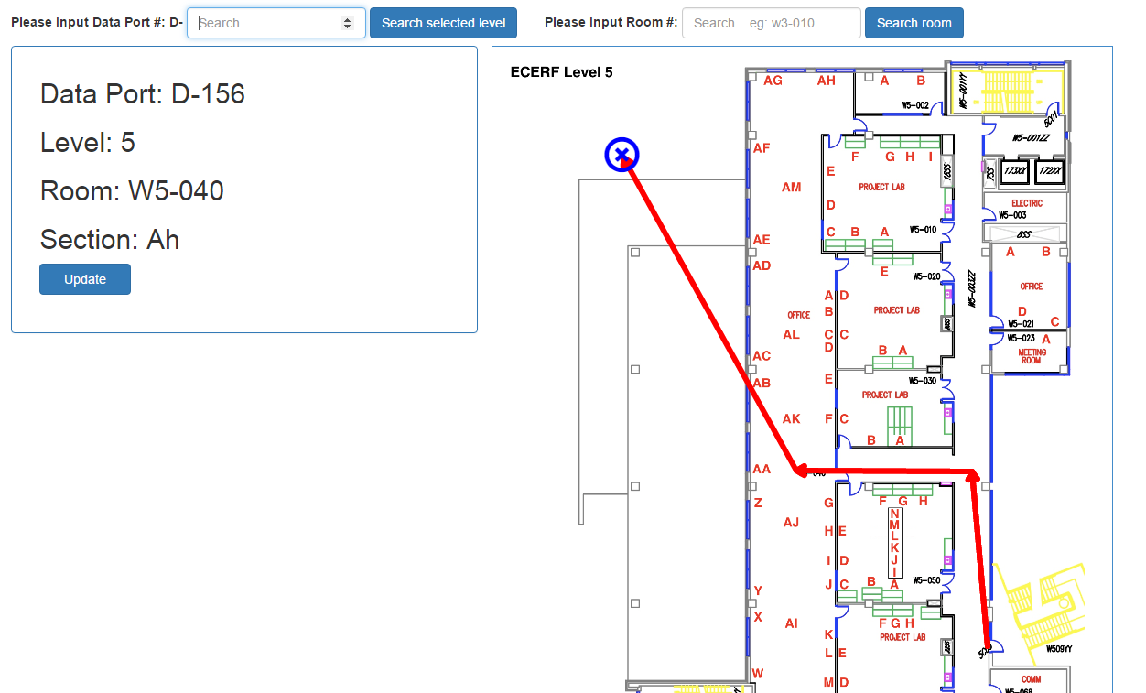
Update Coordinate

Search by Room Number
Inputting the Rom number, a relevant data port list will be displayed. Otherwise an error message will be display.
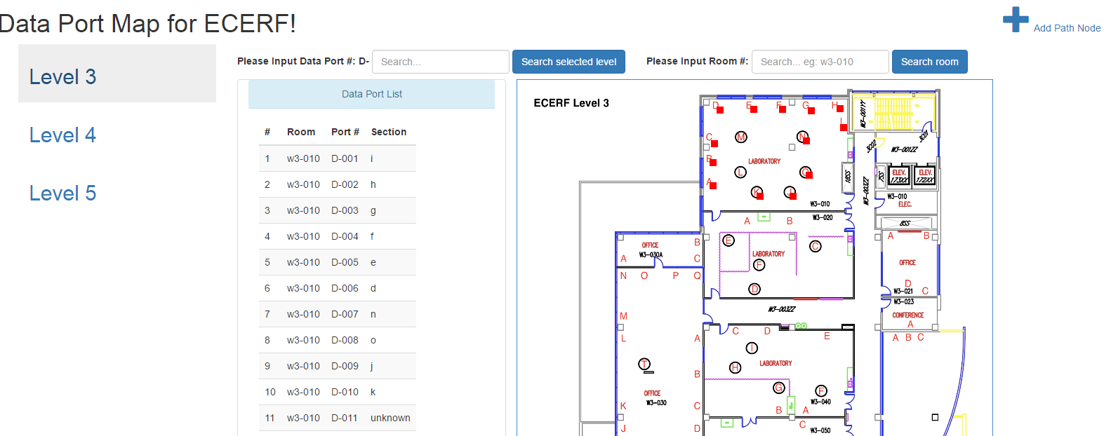
Search Result

Add Path Nodes
This function will be used only when a renovation blocks the hallway in the future and you need to create a node to draw the shortest path. Nodes for existing data ports already exist in database. In addition, these node coordinates will be updated automatically when you update the corresponding data port coordinates.
Selecting a level, entering a node name, clicking on the map to get coordinate and clicking AddNote are all you need to do to add a path node.
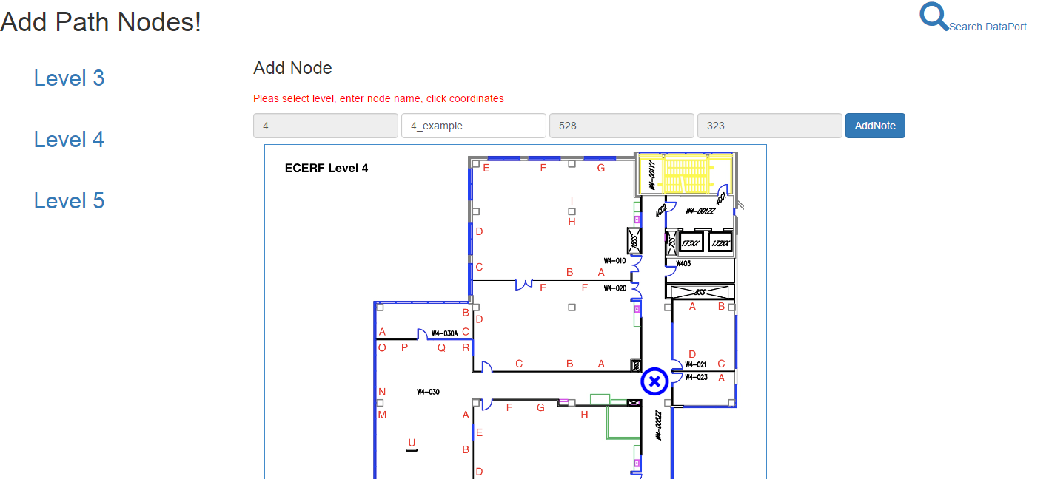
Add Path Nodes

Manage Edges
If you plan to add or delete a lot of edges at the same time, we strongly suggest you use MySQL query/queries script. It is must easier and timesaving. In the database, an edge is undirected. Therefore A=>B or B => A is equivalent to A ⬄B.
Selecting floor and then selecting Start Node and End Node are all you need to do to add or delete an edge.
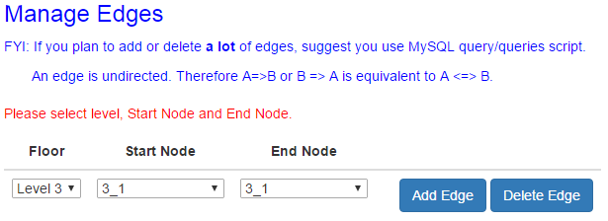
Manage Edges

